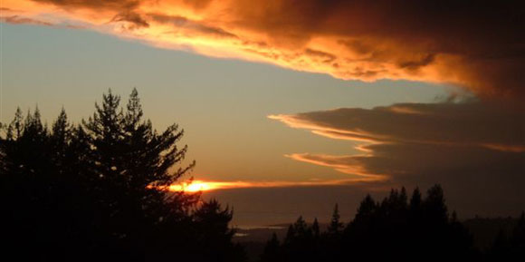

Mount Madonna Center
Day, Date
NOTES:
You arrive on ______, ______ and depart on ______, _______. If you arrive in the evening and the gate is closed you can open it
by entering this code in the keypad: #XXXX. That's POUND XXXX.
Receipt #XXXXX
Dear ______,
We have received your deposit/payment of $_____ and have scheduled you for your personal retreat, as you requested.
For lodging you have been given a "________" reservation.
We suggest that you bring the following:
- towel (since towels are not provided)
- alarm clock
- flashlight
- warm clothing for cool nights and mornings
- comfortable clothes and shoes for a rural setting
- a swimsuit for lake swimming or hot tubbing
- water bottle
Please note that the rainy season in this part of California can begin as early as October 1, and end as late as May 1; make sure you pack waterproof clothing during that season. Also, if you are camping at any time of the year, it is possible your tent may get “rained on” via fog condensation drips from the redwood trees.
You may wish to bring slippers, as shoes are not worn indoors.
We provide shampoo, conditioner, body wash, and lotion in all shower facilities.
Our food service is strictly vegetarian – no meat, fish, fowl, or eggs. At each meal there are non-dairy and non-gluten options, and foods containing dairy and gluten are clearly marked. Our check-in time is 4:00 pm. Rooms may not be available prior to the check-in time. Your first meal is dinner. If you wish to arrive earlier and have lunch (12:30-1:30), you will need to make a lunch reservation by phoning 408-846-4065 at least 24 hours in advance.
Please DO NOT bring the following onto the property:
- food
- drugs
- alcohol
- pets
- incense
DO NOT wear scented body products.
If you are a snorer, please request a single room or cabin; however, most of our accommodations are shared. If you are worried about someone in your room who might snore, we suggest wearing earplugs (provided), or waking the snorer. We will make an attempt to change your lodging the next day if you find yourself in a room with a snorer, but cannot guarantee that it would be possible; no changes can be made in the middle of the night.
If you are bringing your own vehicle to sleep in, then when you check in, you will be shown several options for places you can park the vehicle you are staying in. Kindly do not park anywhere else than the "own vehicle" spots. If you are bringing a vehicle longer than 24', please phone 408-846-4064 so we can discuss details. We have some electrical hook-up spots available, but no water or sewer hook-ups.
Due to extreme fire precautions DO NOT bring or use incense, candles, kerosene lamps, etc.
Your retreat begins on the afternoon of _________, ___________.
Dinner is served from 5:00 pm to 6:00 pm.
Our check-in time is 4:00 pm. Rooms may not be available prior to the check-in time. Check with the Programs Office if you plan to arrive before 4:00 pm.
Check-out time is _________ on the day of your departure. Please be sure to vacate your room prior to the check-out time.
The office closes at 5:00 pm.
If you will ARRIVE LATER than __________ please call ____________ to let us know.
Notes are posted in the Community Building lobby for late arrivals.
We will save dinner for you on request.
Your retreat will end at ________ on ________, _________.
Cancellation Policy: _____________
We look forward to seeing you here soon.
Sincerely,
_______________

Finances

Charges
Amount | What
$0 | Total

Payments
Amount | What
$0 | Total

Balance Due
$0

Address and Contact Information
Mount Madonna Center - 445 Summit Rd, Watsonville, CA 95076
Phone | 408-846-4064 or 408-847-0406
Fax | 408-847-2683
Email | programs@mountmadonna.org
Business Hours | Monday-Thursday 9:00-5:00  Friday 9:00-5:30  Saturday 11:00-5:00
Map/Directions | Use only maps on our website, or directions below. Do not use GPS, Mapquest or Yahoo Maps.
For massage and other procedures at Kaya Kalpa Wellness Center see below.

TRANSPORTATION
Please refer to the following website for directions and transportation: http://mountmadonna.org/directions/airport.html.

Directions
Do not use any GPS system or any directions from Mapquest, or Yahoo Maps or any other outside source. Use only the directions below, or see the maps on our website.
On the west coast of Central California approximately 2 hours driving time south of San Francisco (more if traffic is heavy), Mount Madonna Center overlooks Monterey Bay from the Santa Cruz mountains between Santa Cruz and Watsonville, 3.5 miles off Highway 152.
From Highway 1, THE COAST:
Take Hwy 1 to Watsonville, then take the Airport Blvd exit. Go approximately 3 miles on Airport Blvd, then left onto Hwy 152 East. At the top of the mountain turn left just after Mount Madonna Inn, into Mt Madonna County Park (Pole Line Rd). Follow the yellow line through the park and continue straight through the 4-way stop onto Summit Rd. The Center is 1.5 miles further on the left (445 Summit Rd).
From Highway 101, INLAND:
Take Hwy 152 West at Gilroy. Go approximately 10 miles through Gilroy and up the mountain. At the top of the mountain, turn right into Mt Madonna County Park (Pole Line Rd). If you come to Mount Madonna Inn on your right, you've just missed your turn. Follow the yellow line through the park and continue straight through the 4-way stop onto Summit Rd. The Center is 1.5 miles further on the left (445 Summit Rd).
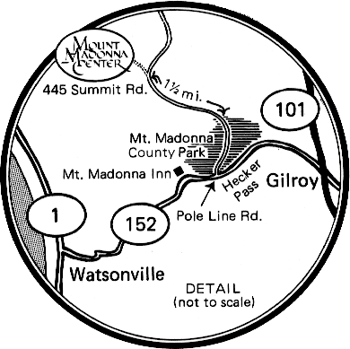
For information about other forms of transportation to the center click here.

Kaya Kalpa Wellness Center
massage, ayurvedic therapy, bodywork
Kaya Kalpa means rejuvenation of body and spirit and our professionally trained practitioners are dedicated to your well-being. We offer a variety of Ayurveda therapies, traditional massage and other body therapies to enhance your stay at Mount Madonna Center. Nestled among majestic oak and redwood trees, on 355 acres overlooking Monterey Bay, Kaya Kalpa Wellness Center offers an oasis for relaxation, health and nurturing.

For more information see our website: www.MountMadonna.org/kayakalpa

